**INFO 3306 WEB APPLICATION DEVELOPMENT**

**FINAL PROJECT PROPOSAL**

TITLE: HOSPITAL RESERVATION SYSTEM

LECTURER:​ MUHAMAD SADRY BIN ABU SEMAN

GROUP KHAYR

|  |  |  |
| --- | --- | --- |
| 1 | IZZAT IZZQY BIN JASME | 1722563 |
|  |  |  |
| 2 | MD ABU HAMED | 1428315 |
|  |  |  |
| 3 | MOHD HANIF HAZIQ BIN MOHD ARSYAD | 1724821 |
|  |  |  |

**INTRODUCTION**

We want to develop a reservation system for a hospital specifically for covid-19 related. By using this system, users can know their symptoms and the system will determine whether they should book an appointment to the hospital. Our system will prioritize the users with the worst of symptoms and will proceed straight to appointment reservation. These reservations should be tended to immediately and will be processed as soon as possible.

**OBJECTIVES**

Our main objective from this project is to create a complete automated system that will help thousands of people from queuing in a long line or get confused by the wrong information that is online. People with less symptoms can just stay at home and self-quarantine and eventually will help the frontliners as well. They will treat patients with high levels of symptoms and don’t have to worry about exposing one patient to another patient that might not be infected. Also, it will reduce the stress on the reception and front-end staff.

**FEATURES AND FUNCTIONALITY**

By using this website, people can easily book their appointment without having to stand in a line. Also, it will reduce the chance of its users being exposed to covid-19. The hospitals will also be able to run more efficiently if they use the system. Furthermore, this website can help to reduce the amount of misinformation available online and help people from falling victim to panic.

**Defined Elements**

* **View**
  + Welcome page
  + Symptom check page
  + Suggestion page
  + Admission page
  + Admin CURD page
* **Controllers**
  + PagesController
  + SymptomCheck
* **Routes**
  + Web
* **Model**
  + Records
* **ERD**

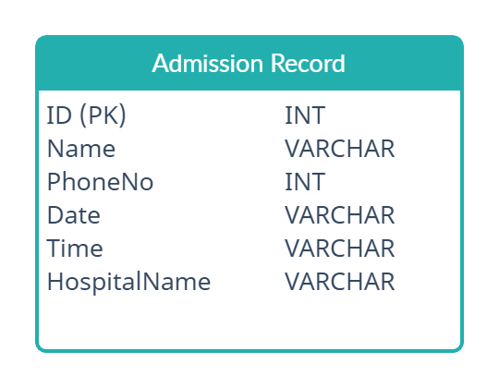

**Sequence Diagram:**

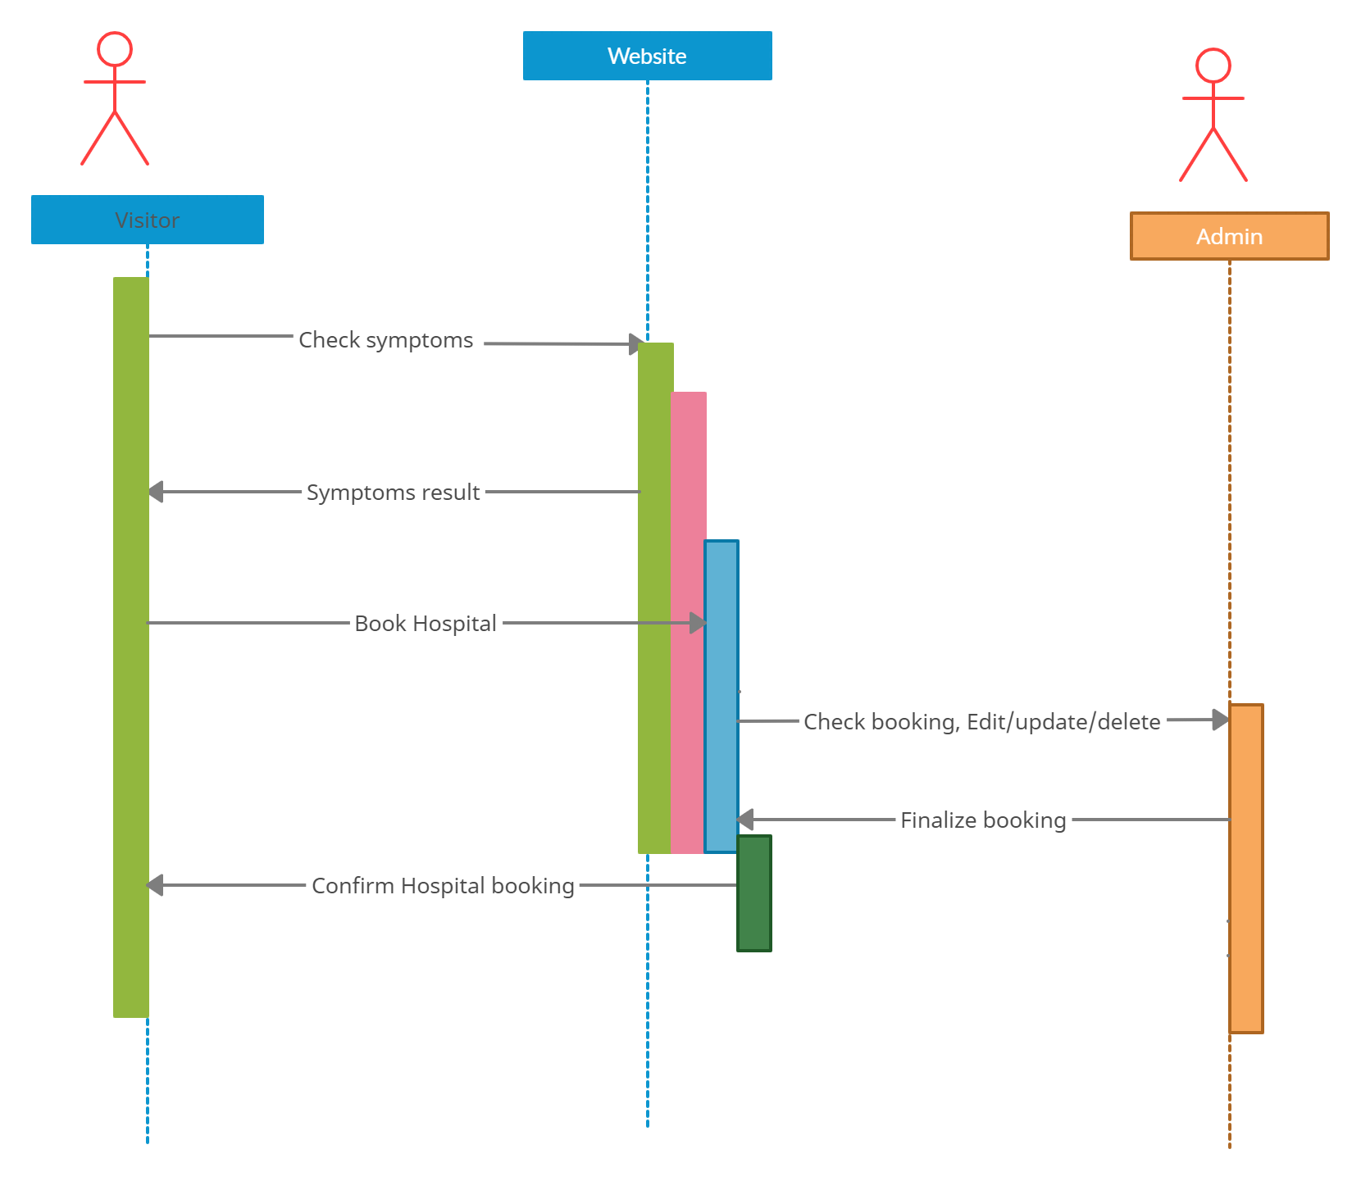

**Reference:**

Moqups.com. 2021. UML Sequence Diagram Template | Moqups. [online] Available at: <https://moqups.com/templates/diagrams-flowcharts/uml-diagrams/sequence-diagram/> [Accessed 1 January 2021].

Visual-paradigm.com. 2021. What Is Entity Relationship Diagram (ERD)?. [online] Available at: <https://www.visual-paradigm.com/guide/data-modeling/what-is-entity-relationship-diagram/> [Accessed 1 January 2021].

Laravel.com. 2021. Installation - Laravel - The PHP Framework For Web Artisans. [online] Available at: <https://laravel.com/docs/8.x> [Accessed 1 January 2021].

Creately.com. 2021. Chart, Diagram & Visual Canvas Software. [online] Available at: <https://creately.com> [Accessed 1 January 2021].